Application For Admission African Girls Congress

Confidential Teacher Evaluation Form

Applicant’s Name:

(First)_____________(Middle)_________________(Last)______________________________

Current School:_____________________________________________________________________

Address of Current School:___________________________________________________________

Telephone (_________________________)

To Parent/Legal Guardian: Please print or type this section and deliver this form to your child’s teacher. The evaluator will email these forms directly to the Moremi Initiative. By submitting this evaluation form and in consideration of having this evaluation and your application considered by Moremi Initiative, you hereby release school, its employees and representatives, the evaluator and the evaluator’s employer from any and all claims and liability that may arise from the providing, obtaining or using of the form and the substance of the information provided by the evaluator. All information provided on the attached evaluation form will be held in strictest confidence and will not be shared with students, parents, or guardians. This will remain confidential and not become part of the student’s permanent academic record.

Signature of Parent or Legal Guardian_______________________ Date_________________

EVALUATOR
How long and in what capacity have you known this applicant? ______________________________________________________________________________

______________________________________________________________________________

Please give explanations to any of the following categories or questions in the “Comments” section:

Academic Characteristics and Qualities

CATEGORIES | Excellent | Above Average | Average | Below Average | No Basis for Judgment
ENGLISH/LANGUAGE ARTS
Reading Comprehension
Grammar
Composition

CATEGORIES | Excellent | Above Average | Average | Below Average | No Basis for Judgment
MATH:
Knowledge of basic skills
Ability to grasp new concepts
Analytical ability

CATEGORIES | Excellent | Good | Fair | Poor | No Basis for Judgment
Oral Expression
Critical/Abstract Thinking Skills
Intellectual Curiosity
Organizational Skills
Study Skills
Motivation
Determination
Creativity
Academic Potential
Oral Expression

Class Participation | Joins in readily | Contributes occasionally | Wants to dominate | Rarely contributes
Ability to work in a group | Always works well | Sometimes | Has difficulty | Has great difficulty
Ability to work independently | Always works well | Needs help occasionally | Needs help frequently | Needs constant help
Ability to complete assignments on time | Always completes on time | Usually completes on time y | Has difficulty Rarely | Has difficulty Rarely
Follows directions | Easily and accurately | Occasionally needs help | Needs much explanation | Rarely
Takes Initiative | Always | Usually | Sometimes | Rarely

Is the applicant currently involved with extracurricular activities? If yes, please explain:

______________________________________________________________________________

______________________________________________________________________________

______________________________________________________________________________

Do you have any reason to question the applicant’s academic or personal integrity? If yes, please explain.
______________________________________________________________________________

______________________________________________________________________________

______________________________________________________________________________

Areas in which the applicant has the greatest strengths:
______________________________________________________________________________

______________________________________________________________________________

______________________________________________________________________________

Areas in which the applicant has the greatest needs:

______________________________________________________________________________

______________________________________________________________________________

______________________________________________________________________________

Describe the ways the applicant contributes to your school community: (character, citizenship, leadership)

______________________________________________________________________________

______________________________________________________________________________

______________________________________________________________________________

Please describe parental support/involvement:

______________________________________________________________________________

______________________________________________________________________________

______________________________________________________________________________

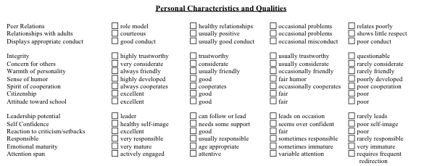

Comments:
______________________________________________________________________________

______________________________________________________________________________

______________________________________________________________________________

Evaluator’s Name____________________________________Signature____________________

Title_____________________________ Date_______________

